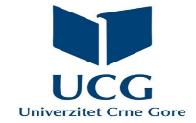

Summer school
Filološki fakultet, Univerzitet Crne Gore
REFLAME YOUR ENGLISH FOR LANGUAGE AND LITERARY STUDIES

Upon the completion of this course, a student will be able to:
1. Demonstrate high levels of communicative competence in vocational English for Language and Literary studies at the B2.2/C1.1 level of the Common European Framework of Reference for Languages;
2. Use standard language norms at all language levels in written and oral communication;
3. Apply advanced grammar knowledge and specialised techniques and skills of written and oral translation and translate texts from English and into English in the field of language and literary studies;
4. Analyse the written or spoken text in detail and comprehensively and recognize key ideas and implicit meaning;
5. Discuss topics on specialized theoretical and practical knowledge related to the latest achievements in the field of language and literary studies.

